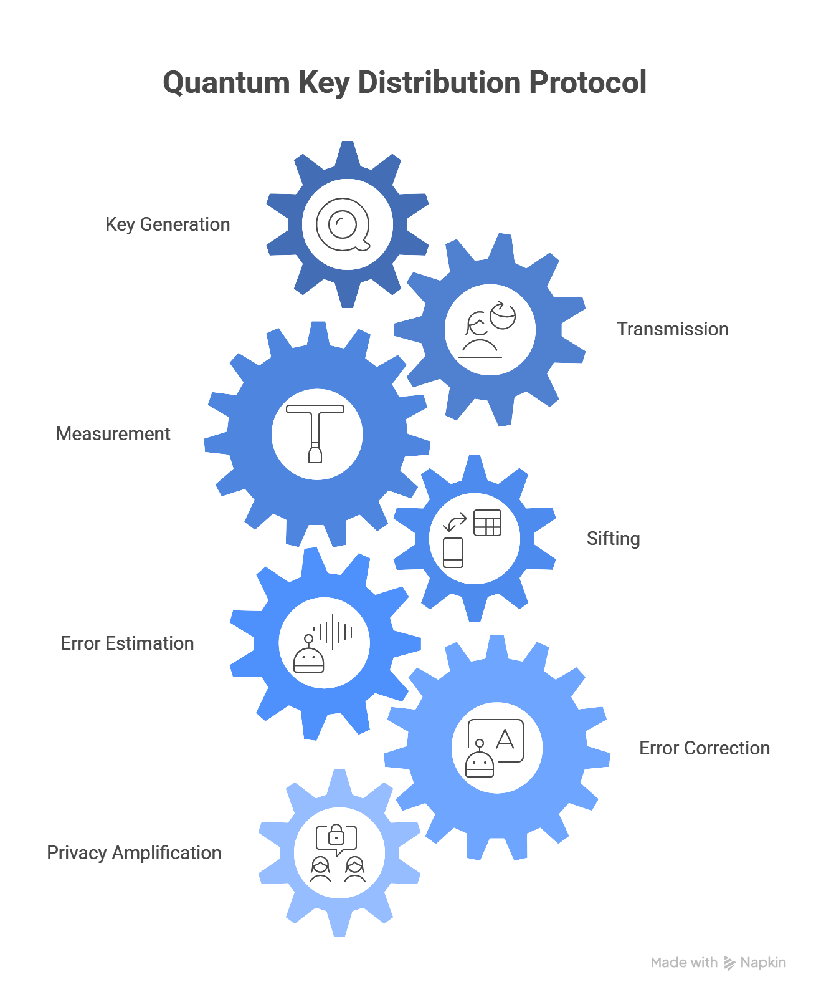

QKD Protocol Steps Overview
1. Key Generation
Alice generates random bits (0/1) and randomly chooses a basis (Z: horizontal/vertical polarization or X: diagonal) for each, encoding them into qubit states like photons.​
2. Transmission
Alice sends the encoded qubits to Bob over a quantum channel (optical fiber or free space) without revealing bits or bases.​​
3. Measurement
Bob randomly selects a measurement basis (Z or X) for each qubit and measures it, collapsing the quantum state to obtain bits.​
4. Sifting
Alice and Bob publicly compare their basis choices via classical channel; they keep only matching-basis bits (~50% sifted key), discarding others.​
5. Error Estimation
They sacrifice a subset of sifted bits publicly to calculate Quantum Bit Error Rate (QBER); high QBER (>~11%) signals eavesdropping.​
6. Error Correction
Classical protocols (e.g., Cascade, LDPC) reconcile remaining bit errors between Alice and Bob without leaking key information.​​
7. Privacy Amplification
A hash function shrinks the key, eliminating any partial information Eve might have gained, yielding identical secure final keys.

